Media Memos

- Students can use Destiny at home check to see what books are in the
media center by using this link: http://64.26.102.182
- Be on the lookout for AR letters which will be sent home November 1.
- Come visit our Book Fair! Books make great gifts for the holidays!
- Book Fair volunteers are still needed! If you can help or know someone else who can please contact me at school. See the dates & times below.
Thank you!
Mrs. Ewalt

Visit our Willards Media Center website
http://willardsmedia.weebly.com
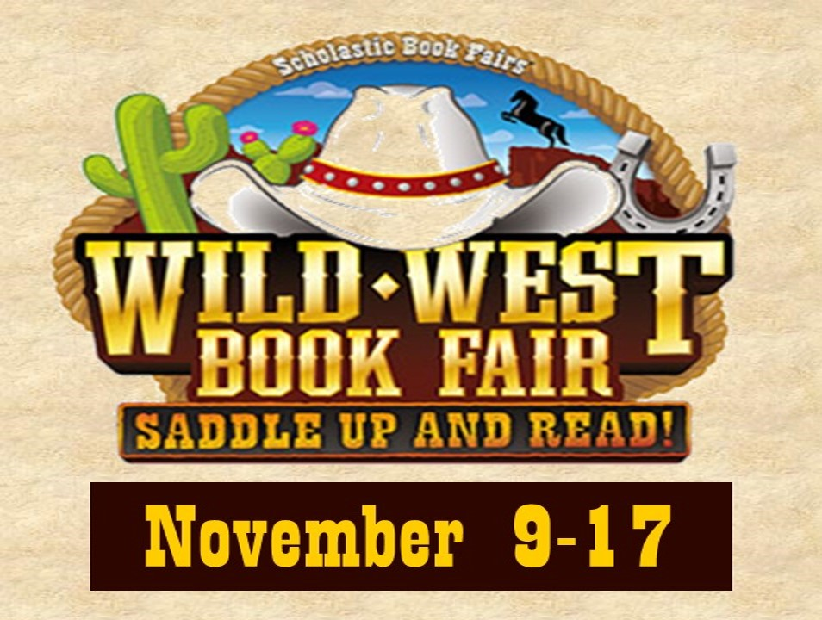
The Book
Fair Is
Coming!

