Media Memos

- Grades 1-3 are checking out books.
- Students can use Destiny at home check to see what books are in the
Media Center by using this link: http://64.26.102.182
- AR will begin October 2 for Grades 1 & 2.
Accelerated Reader (AR) is a computerized program that allows students to take an AR quiz after reading a book. This book can be read in the classroom or at home, but all quizzes will be taken at school. Your child has been given a goal based upon his/her reading level and grade level. All children in grades 1 & 2 are expected to participate in the program. Here’s how it works.
- Students should select and read books on their level. Your child will be able to choose books in their classroom, in the library, and at home that are in the AR database. Books in the library have a colored dot on the book spine that represent the level. If you want to see if books at home are AR books you can visit www.arbookfind.com.
- They will then take a quiz after reading the book. They may take the quiz on the computer in their classroom or in the library. The quizzes consist of multiple choice questions about the book and the computer awards points based on the difficulty of the book and the number of questions that the students answer correctly. Students must choose answers themselves with no assistance from anyone else.
- When they get 25%, 50%, 75%, and 100% of their goal by the target dates, their scores will be posted on the school TV & the Media Center website and their names will be posted on the glass windows of the Media Center. When they reach 100% goal a star will be posted by their name and they will receive recognition at the end of the school year but the ultimate reward is the love of reading.
You can encourage your child by listening to him/her read, making sure they are choosing books that are on their level, asking questions about the book, and keeping track of their progress in AR. You can access your child’s AR information in Renaissance Place Home Connect* anytime from any computer (see Home Connect letter that is coming home). If you have any question please feel free to contact me at school.
Happy Reading!
Vicki Ewalt

Visit our Willards Media Center website
http://willardsmedia.weebly.com
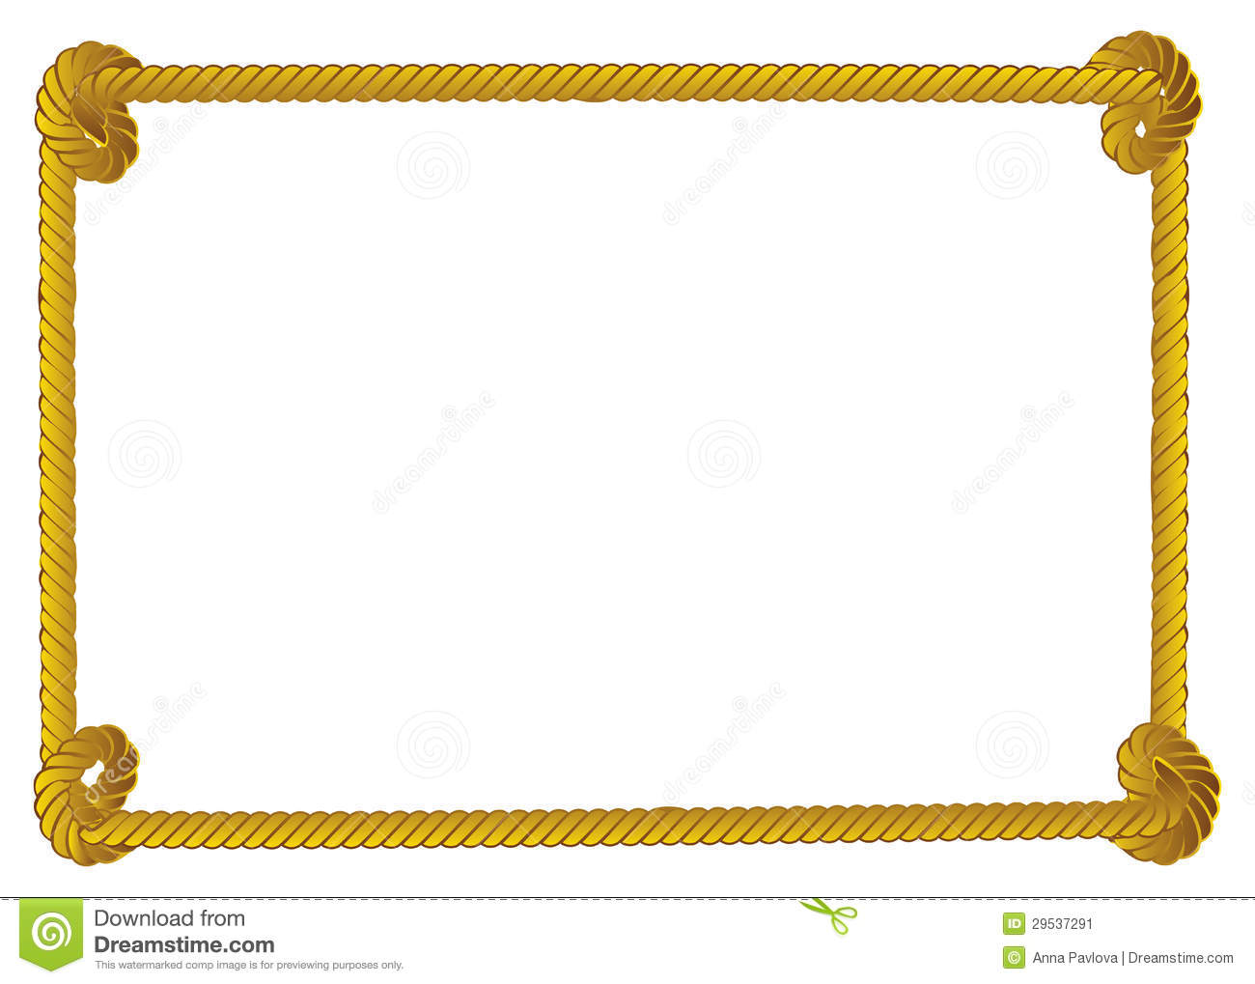
The Book
Fair Is
Coming!

