Media Memos

Visit our Willards Media Center website
http://willardsmedia.weebly.com

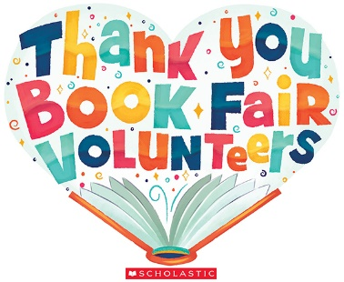
- Thank you for helping to make our Wild West Book Fair a success! A special thanks to those who volunteered and helped to make it happen!
- Students can use Destiny at home check to see what books are in the media center by using this link: http://64.26.102.182
- AR is in full swing for Grades 1 & 2. Students who reach 25% of their goal by Nov. 30 will get their picture in the hall and their name on the TV scroll, in the next Dolphin Press and on our Willards Media Center website.

